1. The part list interfacing is as under

|  |  |  |
| --- | --- | --- |
| # | Electronic Interlocking | KAVACH |
| Make | MEDHA | KERNEX |
| Model no |  |  |
| Interface type | SERIAL | SERIAL |
| Power Supply |  | 5V |
| Other modules |  |  |

1. Connection diagram:

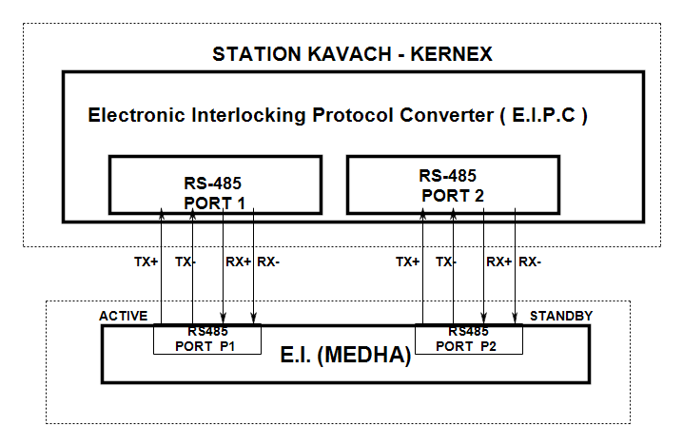

1. Is the power supply duplicated? **YES**
2. Is the communication duplicated? **YES**
3. Whether the communication is point to point? **YES**
4. Whether the communication is Peer to Peer OR Master - Slave? **MASTER – SLAVE**

1. Protocol Sequencing:

KERNEX - SKAVACH

MEDHA-EI

1. Is periodic health check available? **YES**
2. Is time synchronization available? **NO**
3. Entire Request – Response procedure is to be written down below: -
4. **MEDHA - EI Sends a message to SKAVACH which includes VITAL DATA (Application Data).**

SKAVACH will verify the message received from EI.

|  |  |  |
| --- | --- | --- |
| 4. | Periodicity and Timeout: |  |
| (i) | Whether the communication is periodic? | :**YES** |
| (ii) | What is the maximum rate of transfer of data? | : **115200 Baud rate** |
| (iii) | How many maximum number of data bits can be exchanged between EI and KAVACH? | : **1024 Bits / 128Bytes** |
| (iv) | The maximum round trip delay after which communication is said to be lost is | : **1 Second** |
| (v) | The KAVACH (Receiver) cycle time is | : **20 milli seconds** |

1. The Electronic Interlocking (Transmitter) cycle time is: **333 milli seconds**
2. The boot up time of Electronic Interlocking is : **60 Seconds**

(Is it Station – specific?) : **Yes**

1. The boot up time of Stationary KAVACH is :**20 Seconds**

(Is it Station – specific?) :**NO**

1. Handling of duplicate messages:
2. How duplicate messages are detected? By EI: **Using the packet number**

By SKAVACH: **Using the packet number**

1. How duplicate messages are not processed? By EI:

**Stores Last Validated Sequence Number. If any message with same Sequence Number is received, Message is discarded and not processed.**

By SKAVACH: **Stores Last Validated Sequence Number. If any message with same Sequence Number is received, Message is discarded and not processed.**

1. Are duplicate messages stored in event logger?

By EI: **NO**

By SKAVACH: **NO**

1. Handling of out of sequences messages:
2. How out of sequence messages are detected? By EI: **Using the Packet number.**

By SKAVACH: **Last valid packet will be stored at SKAVACH, the next packet sent by the EI shall be incremented by one (or) shall be within the configured range, else the message will not be processed.**

1. How out of sequence messages are not handled? By EI:

**Discarded, If the received Sequence Number is not matches with (Last Validated Sequence Number + ONE)**

By SKAVACH: **Last valid packet will be stored at SKAVACH, the next packet sent by the EI shall be incremented by one (or) shall be within the configured range, else the message will not be processed.**

1. Are out-of-sequence messages stored in event logger?

By EI:  **NO**

By SKAVACH: **NO**

1. Communication Redundancy:
2. KAVACH is standalone system with **2oo2.**
3. Is the Electronic Interlocking System Hot Standby or Warm Standby: **2 x 2oo2**

EI (S)

1. Schematic showing the communication arrangements without having impact original architecture of EI and SKAVACH is shown below: -
2. The entire message flow explaining communication redundancy is as under: -

EI (S) (min 2oo2)

EI (P) (min 2oo2)

**Redundant**

**SKAVACH** **(min 2oo2)**

* 1. SKAVACH request to both EIs in hot/warm standby: **SKAVACH will receive the messages from both the EI’s.**
  2. Both EIs respond and reply: **SKAVACH will receive the messages from both the EI’s.**
  3. SKAVACH Validates: **By checking the packets received from both the EI’s.**

1. Is the connection between EI and KAVACH direct? **YES**
2. If it is not direct, i.e., through a channel which is connected to other devices then the precautions taken to mitigate vulnerability and Interference shall be listed below: -

|  |  |  |  |
| --- | --- | --- | --- |
| # | Mitigation Measures | Phase of  mitigation | Responsibility  (EI/Kavach/Railways) |
| (i) |  |  |  |
| (ii) |  |  |  |
| (iii) |  |  |  |

1. (i) Is Tx sequence number available from EI side? **YES**
   1. Is Tx sequence number generated by EI unique? **YES**
   2. How is it unique? **Unique Sequence Number for every Vital data message.**
   3. How S- KAVACH validated this? **Last valid packet will be stored at SKAVACH, the next packet sent by the EI shall be incremented by one (or) shall be within the configured range, else the message will not be processed.**
2. i) Is Tx sequence number available from SKAVACH side? **NO**
3. Is Tx Sequence number generated by SKAVACH unique? **Not Applicable**
4. How is it Unique? **Not Applicable**
5. How S-KAVACH validated this? **Not Applicable**
6. Time Stamp: -
7. Time stamping process of EI: **Optional**

.

1. Time stamping process of S-KAVACH: **Through GPS**
2. Is time stamping process of EI and S-KAVACH same? **NO**
3. If time stamping is not same, the following are the steps taken to resolve the issue: **This will not impact the communication between EI-SKAVACH.**

1. How leap year is handled? **Not Applicable.**
2. It time Zone having impact on design? IST/GMT: **NO**
3. IP address:

**“This is serial interface protocol IP Addresses are not applicable”.**

1. KAVACH system must ensure that the IP address provided by EI is only used for its system/PC which is connected to EI.
2. KAVACH system shall inform EI OEM about IP address which they use at their systems (This is to avoid any network conflict between both systems)
3. CRC:
4. What is the length of CRC of the Interface Protocol?

**32-Bit CRC for Entire message and 32bit CRC for Vital data in the Message.**

1. If it is less than 27 – bit, what techniques the OEM is following to meet the required level of THR for SIL-4? **Not Applicable.**
2. Version Control:
3. How version control of executive logic is managed in EI?
4. How version control of executive logic is managed in S-KAVACH?

**Version control is managed by maintaining the Executive files through third party application called CLM (collaborative lifecycle management).**

1. How version control of application logic is managed when bits required to be sent are modified in EI?
   1. Does the CRC of application logic changes? **YES**
   2. If yes, how safety validation of application logic is ensured?

**As per the protocol it is not possible to detect the change in Application logic as there is no parameter, which provides details about application logic CRC/Version.**

* 1. What measures the Firm is planning to make it independent of application logic CRC?

**EI Can maintain separate CRC for relays exchanged with KAVACH.**

* 1. How version control of data being sent through the EI-KAVACH Interface is ensured?

**As per the protocol it is not possible to detect the change in Application logic as there is no parameter, which provides details about application logic CRC/Version.**

* 1. If version control of data sent is not ensured what validation measures are taken by EI OEM to ensure safety?

1. How version control of application logic is managed when bits required to be received are modified is S-KAVACH? **The Application CRC will be modified and same will be configured at SKAVACH.**
   1. Does the CRC of KAVACH TOC application logic change? **YES**
   2. If yes, how safety Validation of KAVACH TOC application logic is ensured?

**Application Logic shall be re-verified by a FAT with the independent V&V team.**

* 1. What measures the firm is planning to make it independent of KAVACH TOC application logic CRC?

**SKAVACH application logic depends on the relays statuses, presently no plans  
to make it independent.**

* 1. How version control of data being received through the Kavach – EI interface is ensured?

**Application CRC’s of EI and SKAVACH shall be maintained.**

* 1. If version control of data sent is not ensured, what validation measures are taken by KAVACH OEM to ensure safety?

**Application CRC’s of EI and SKAVACH shall be maintained.**

1. Grouping of Relays / Acquiring relay information: -
   1. EI shall indicate the total number of axle counters/ track circuits, points, lamp providing relays, other relays in a message. The message bytes shall be standardized and submitted to RDSO by KAVACH OEMs.

**Presently the Bit list is submitted to respective railway board.**

* 1. EI shall keep on sending all the relays status every cycle on the KAVACH Interface port. **YES, the relay statuses are received for every 333ms.**
  2. This shall be a default activity in all new EI installations.
  3. The existing installations are also to be gradually migrated.
  4. The bit chest shall be provided to Railways by EI OEM.
  5. KAVACH OEM shall use this bit-chart and fetch the required relay information.

The test details shall be as under: -

* 1. The logs showing the status of relays between the Data logger output and port of KAVACH shall be compared for 30 days and SD shall be less than 10-8 in an hour. Report to be enclosed.